Azure Migrate
About Azure Migrate - Azure Migrate | Microsoft Learn

Plan
After you make the decision to migrate to Azure, the next important phase of migration is planning. To plan migration in detail, use Azure Migrate assessments to find:
- Azure readiness: Assess whether on-premises servers, SQL servers, and web apps are ready for migration to Azure.
- Right-sizing: Estimate the size of Azure virtual machines (VMs), the Azure SQL configuration, and the number of Azure VMware Solution nodes after migration.
- Azure cost estimation: Estimate costs for running on-premises servers in Azure.
- Dependency analysis: Understand the network dependencies between servers in your datacenter so that you can make high-confidence migration plans without missing any critical dependency. Learn more about dependency analysis.
Create a Azure Migrate Project
Under Assenssment Tools We have Discovery, Dependency analysis,Assess and Overview
Click Discover to choose the where the VM located (VMwhare ,Hyper-V or physical Server)
Generate the Project Key
Download the Azure Migrate appliance (.vhd file or zip file )
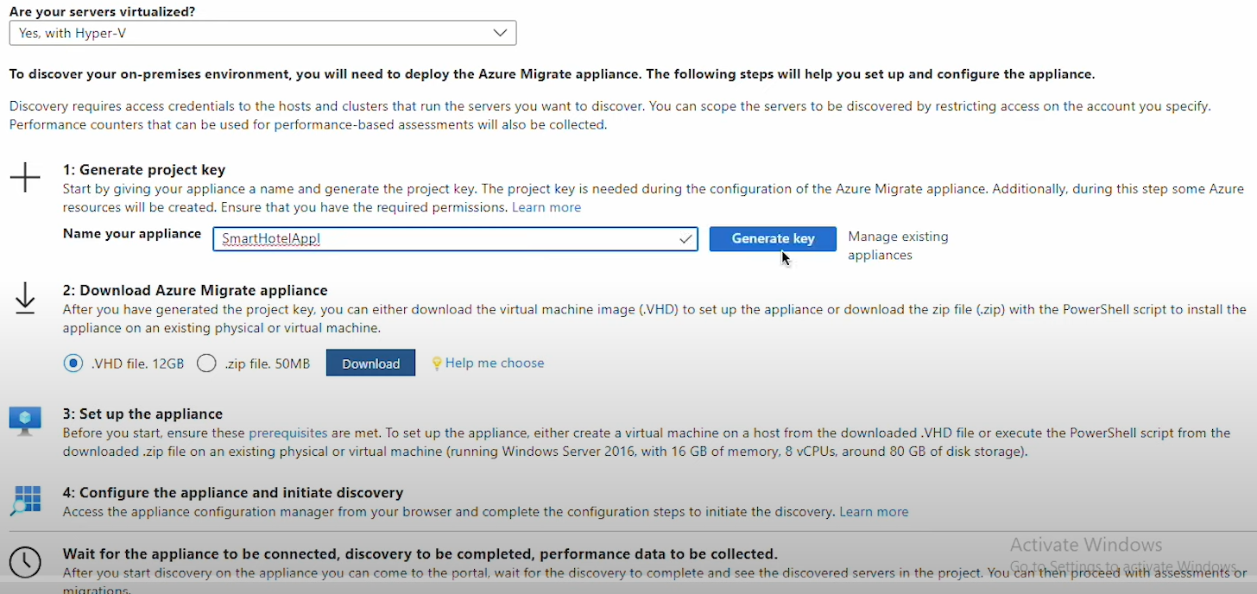

Import the VHD file as a virtual machine in the Hyper-V

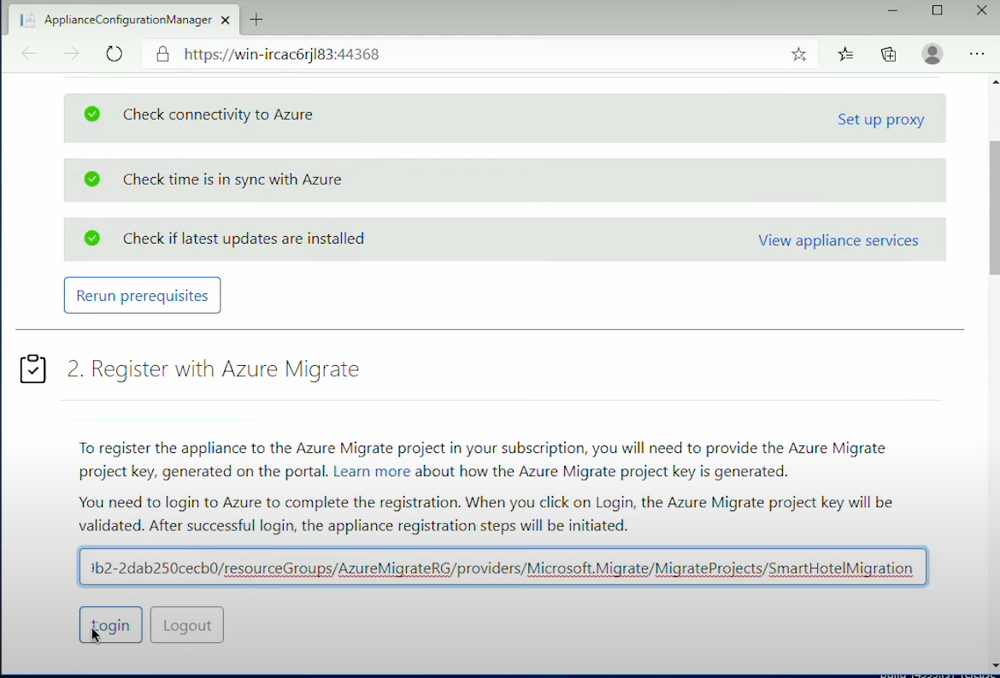
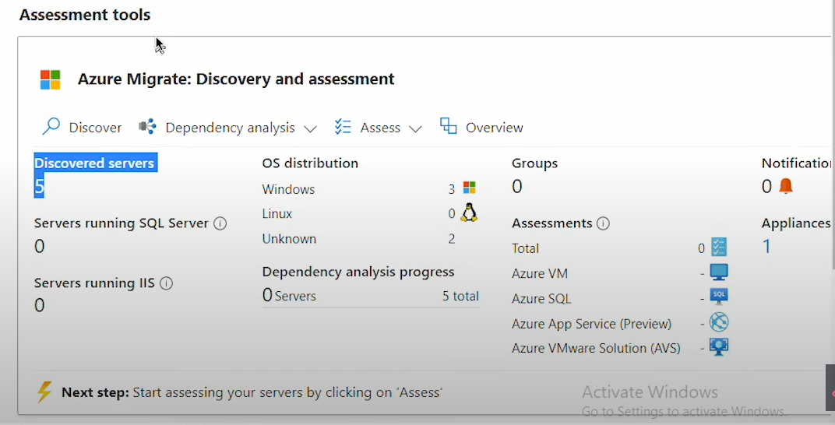
Create assessment Group
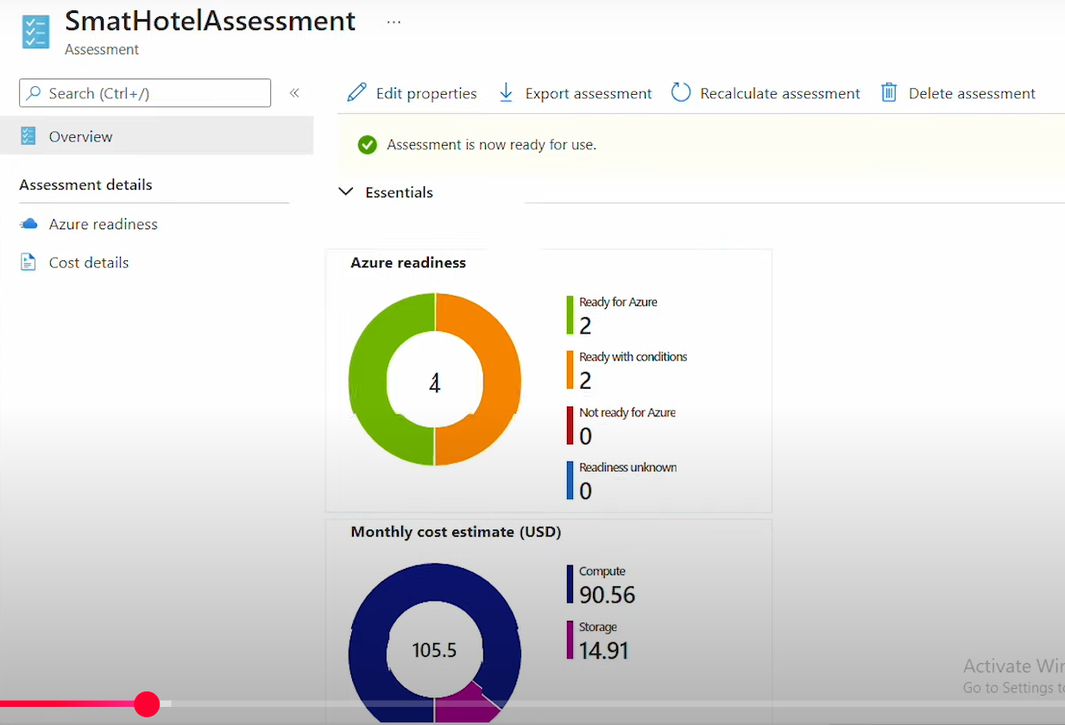

Click the Group

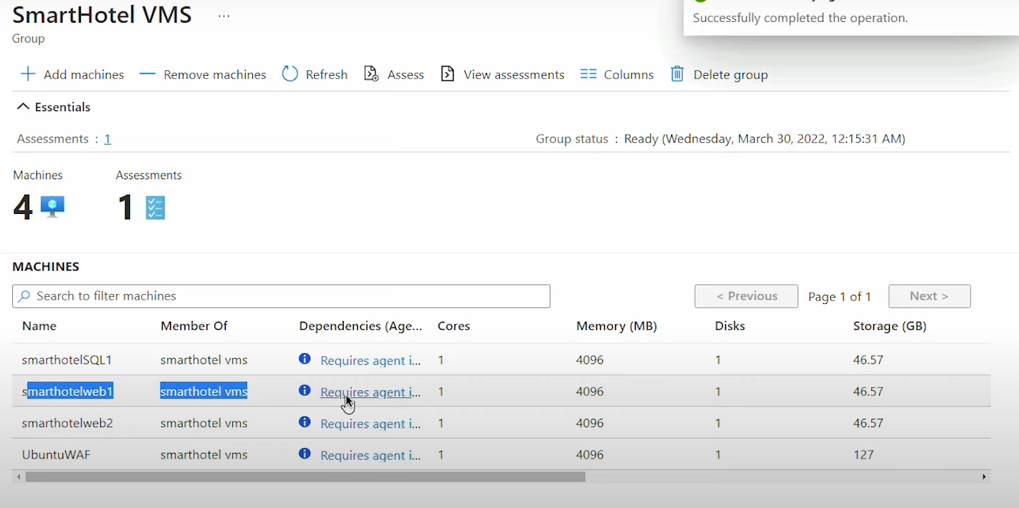

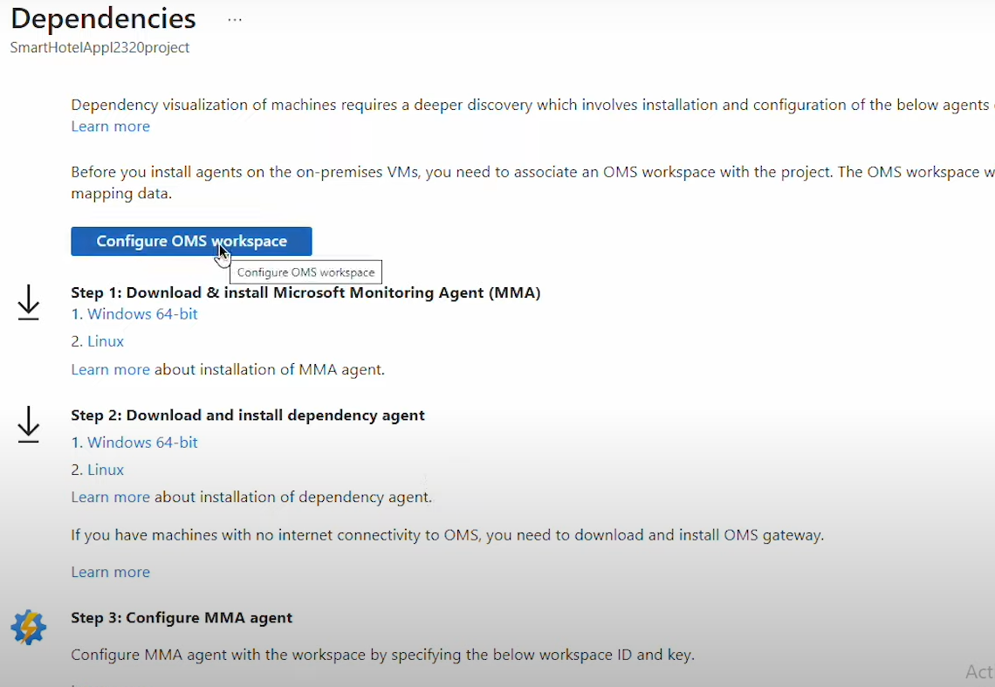
Create a Storage account :
Create a Private endpoint :
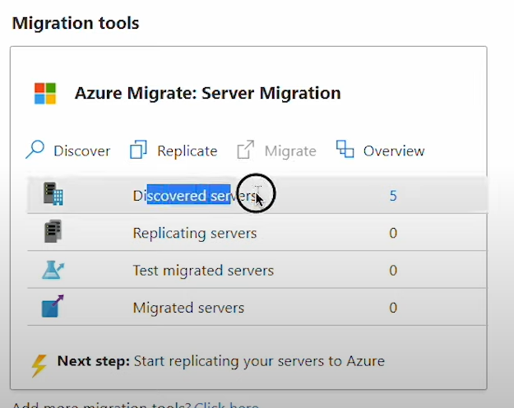

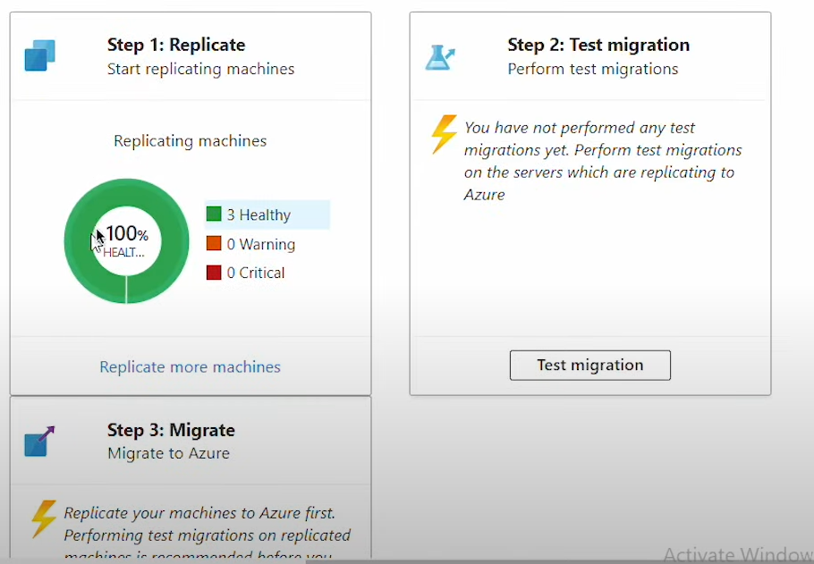

✅ Step-by-Step: Migrate Hyper-V VMs to Azure using Azure Migrate

🟦 1. Create an Azure Migrate Project
- Go to the Azure portal.
- Search for Azure Migrate.
- Click + Create project.
- Choose your Subscription, Resource Group, and give the project a name.
- Select Geography where your project data will be stored.

🟩 2. Set Up the Assessment Tool
Under the Assessment Tools section:
- You’ll see:
  - Discovery
  - Dependency Analysis
  - Assess
  - Overview

🟨 3. Start Discovery
- Click Discover under Servers, databases, and web apps.
- Choose the Hyper-V option (can also select VMware or physical server if needed).
- Azure will prompt you to generate a project key.

🟧 4. Download and Configure Azure Migrate Appliance
- Download the Azure Migrate appliance:
  - Choose .VHD file for Hyper-V.
  - (Or .zip for physical/VMware environments.)
- Import the VHD as a virtual machine in your Hyper-V Manager.
- Start the VM and configure networking and registration using the project key.

🟫 5. Perform Discovery
- The appliance connects to the on-prem Hyper-V environment.
- It discovers:
  - Virtual machines
  - CPU, memory, disk usage
  - Performance data

🔷 6. Enable Dependency Analysis (Optional but recommended)
- Enable this to analyze communication between servers.
- It helps you group dependent VMs during migration planning.

🟪 7. Create an Assessment Group
- In Azure Migrate portal:
  - Go to Assess > Create Assessment
  - Add discovered VMs into an Assessment Group
  - Define target Azure settings (region, pricing tier, etc.)
  - View Azure readiness, size recommendations, and cost estimates.

🟫 8. Prepare Target Environment in Azure
- Create a Storage Account for storing VM disks if needed.
- Create a Private Endpoint if required for secure connectivity.
- Set up Resource Groups, VNets, and NSGs for migrated resources.

🟨 9. Replicate and Migrate
- Use Azure Migrate: Server Migration tool to replicate selected VMs.
- After successful replication:
  - Perform a Test Migration to validate VM functionality.
  - Schedule and execute the Final Cutover.

✅ 10. Post-Migration
- Validate VM health and services.
- Configure monitoring, backup, and cost optimization.
- Decommission old on-prem infrastructure if not needed.

🧭 Decide Phase
Discover and assess all servers, workloads, and dependencies across environments.
Group workloads into applications and prioritize them for migration.
Build a business case by envisioning cost savings and ROI.

📋 Plan Phase
Perform detailed assessments to choose the right migration strategy.
Select target Azure services, estimate costs, and address readiness or blockers.
Create a high-confidence migration plan with timelines and dependencies.

☁️ Execute Phase
Perform large-scale migrations securely with minimal or no data loss.
Use Azure’s integrated migration tools to modernize workloads.
Track, monitor, and manage migration execution centrally.

🔹 Agentless Migration (DEFAULT)
How it works
- Appliance communicates with:
  - VMware vCenter
  - Hyper-V host
- Uses snapshots
- No agent inside VM
Used for:
- VMware
- Hyper-V
Pros
✅ No OS changes
✅ Easy
✅ Low risk

🔹 Agent-Based Migration
How it works
- Install Mobility Service agent inside VM
- Tracks disk changes
Used for:
- Physical servers
- Some special OS cases
Cons
- Requires OS access
- Slight overhead

Agent Comparison
Feature | Agentless | Agent-based
VMware | ✅ | ❌
Hyper-V | ✅ | ❌
Physical servers | ❌ | ✅
OS access needed | ❌ | ✅

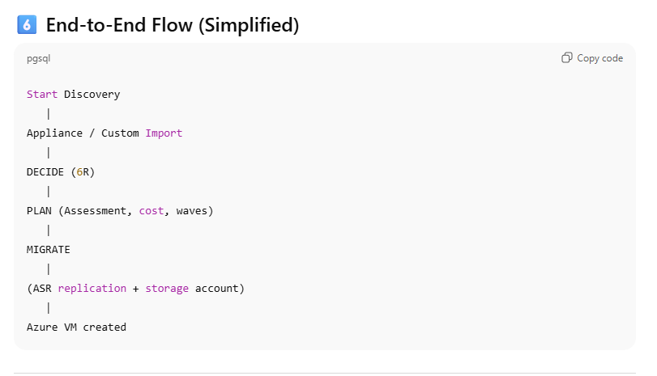

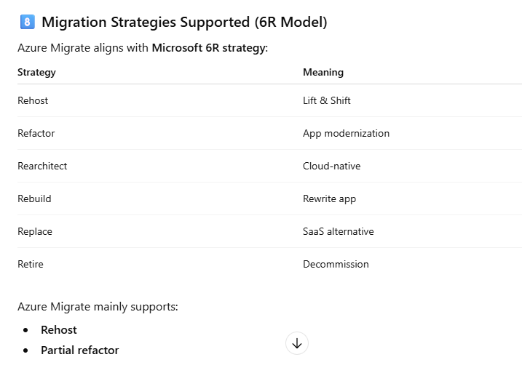

VPN is not Required Outbound 443 is fine from Virtual appliances

